**Registration Form**

National Youth Orchestra | Dubai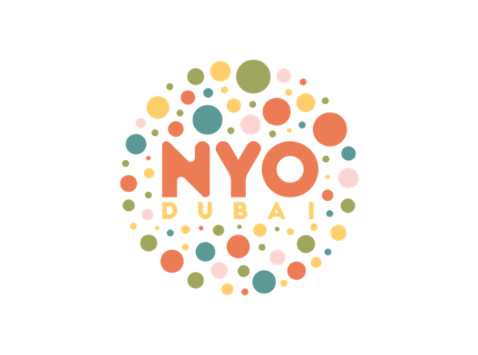

2023-2024

[www.nyo.ae](http://www.nyo.ae)

**The National Youth Orchestra of Dubai offers both educational training as well as performance opportunities at prestigious venues such as Dubai Opera, Global Village, The Theatre at the MOE and Cultural Center of Abu Dhabi, The Emirates Palace Abu Dhabi and more!**

**Weekly rehearsals are at Nord Anglia International School, Dubai on Sundays at the following times:**

**12:30pm-2:30pm National Youth Orchestra Junior Division**

**1:30 pm – 4:00 pm National Youth Winds Orchestra (with percussion)**

**3:00pm - 5:00/5:30pm National Youth Orchestra**

**Termly Fees are AED 1890 (incl VAT) payable before the first session by bank transfer OR in cash in a marked envelope at the first session. See bank details below for transfers**

**NYO t-shirts are AED 100 – please indicate if you would like S, M or L for your child and pay by transfer or by cash**

**Size: S M L available……………….**

**Please fill out the following in CLEAR CAPITAL LETTERS and email/send/scan to admin@encore.co.com**

**Name:**…………………………………………………………………………………………………………………………………….

**Age**: ………………

**Date of Birth:** (day/month/year)……………………………………………………………………………………………….

**School name**:……………………………………………………………………………………………………

**Instrument:**……………………………………………………………………………………………………..

**Performance Level**:………………………………………………………………………………………………………………..

Previous Ensemble Experience i.e., Chamber Music, Orchestra, Choir, etc.

………………………………………………………………………………………………………………………………………………………………………………………………………………………………………………………………………………………………………………………………………………

Instrumental Teacher’s Name, Email and Telephone Number:

…………………………………………………………………………………………………………………………………………………………………...

**Parent/Guardian**:……………………………………………………………………………………………………………………..

**Address:**…………………………………………………………………………………………………………………………………….

**Email**:……………………………………………………………………………………………………………………………………….

**Contact Number**:……………………………………………………………………………………………………………………….

Please note any medical conditions (of your child) that we should be aware of:

……………………………………………………………………………………………………………………………………………………

Please note any food allergies that your child may have:

……………………………………………………………………………………………………………………………………………………

Please sign here to allow your child’s images to be used in our online and printed collateral:

……………………………………………………………………………………………………………………………………………………

**Thank you for your participation and commitment to the National Youth Orchestra Dubai and we ask you to note the importance for regular attendance at rehearsals.**

**\*Please note that all our staff have the *International Educare Child Protection Certification***

**Please make termly payments of AED 1890 (incl VAT) to:**

**Account Name: COUNTERPOINT PERFORMING ARTS AND MUSIC LLC**

**Bank Name: Commercial Bank of Dubai**

**Branch: Main Branch  
Account #: 1002276192**

**IBAN: AE040230000001002276192**

**SWIFT Code: CBDUAEAD**



**Counterpoint Performing Arts and Music**

**DED License 808658**

**P.O. Box 943346, Dubai, UAE**

**Tel: +971544471889**